2015 IEEE/RSJ International Conference on Intelligent Robots and Systems
September 28 – October 03, 2015, Hamburg, Germany

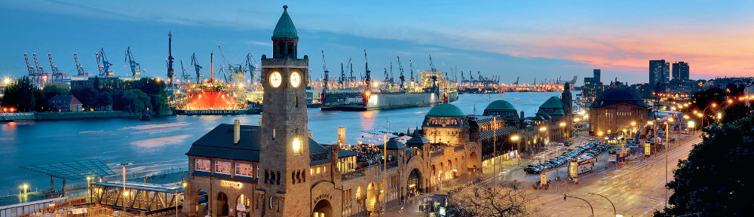

Robot Competition Title
Organizers: A. Derpington, B. Herp, C. Derp, D. Herpington, …
http://www.link-to-this-workshop.edu
(a draft version of this web page should be available and will be linked to IROS 2015 webpage)

The Challenge (max. 300 words)
Lorem ipsum dolor sit amet, consetetur sadipscing elitr, sed diam nonumy eirmod tempor invidunt ut labore et dolore magna aliquyam erat, sed diam voluptua. At vero eos et accusam et justo duo dolores et ea rebum. Stet clita kasd gubergren, no sea takimata sanctus est Lorem ipsum dolor sit amet. Lorem ipsum dolor sit amet, consetetur sadipscing elitr, sed diam nonumy eirmod tempor invidunt ut labore et dolore magna aliquyam erat, sed diam voluptua. At vero eos et accusam et justo duo dolores et ea rebum. Stet clita kasd gubergren, no sea takimata sanctus est Lorem ipsum dolor sit amet. Lorem ipsum dolor sit amet, consetetur sadipscing elitr, sed diam nonumy eirmod tempor invidunt ut labore et dolore magna aliquyam erat, sed diam voluptua. At vero eos et accusam et justo duo dolores et ea rebum. Stet clita kasd gubergren, no sea takimata sanctus est Lorem ipsum dolor sit amet. Lorem ipsum dolor sit amet, consetetur sadipscing elitr, sed diam nonumy eirmod tempor invidunt ut labore et dolore magna aliquyam erat, sed diam voluptua. At vero eos et accusam et justo duo dolores et ea rebum. Stet clita kasd gubergren, no sea takimata sanctus est Lorem ipsum dolor sit amet. Lorem ipsum dolor sit amet, consetetur sadipscing elitr, sed diam nonumy eirmod tempor invidunt ut labore et dolore magna aliquyam erat, sed diam voluptua. At vero eos et accusam et justo duo dolores et ea rebum. Stet clita kasd gubergren, no sea takimata sanctus est Lorem ipsum dolor sit amet. Lorem ipsum dolor sit amet, consetetur sadipscing elitr, sed diam nonumy eirmod tempor invidunt ut labore et dolore magna aliquyam erat, sed diam voluptua. At vero eos et accusam et justo duo dolores et ea rebum. Stet clita kasd gubergren, no sea takimata sanctus est Lorem ipsum dolor sit amet.

RULES and ASSESSMENT (max. 200 words)
The rules and assessment of this …... Lorem ipsum dolor sit amet, consetetur sadipscing elitr, sed diam nonumy eirmod tempor invidunt ut labore et dolore magna aliquyam erat, sed diam voluptua. At vero eos et accusam et justo duo dolores et ea rebum. Stet clita kasd gubergren, no sea takimata sanctus est Lorem ipsum dolor sit amet. Lorem ipsum dolor sit amet, consetetur sadipscing elitr, sed diam nonumy eirmod tempor invidunt ut labore et dolore magna aliquyam erat, sed. At vero eos et accusam et justo duo dolores et ea rebum. Stet clita kasd gubergren, no takimata sanctus est Lorem. The rules and assessment of this …... Lorem ipsum dolor sit amet, consetetur sadipscing elitr, sed diam nonumy eirmod tempor invidunt ut labore et dolore magna aliquyam erat, sed diam voluptua. At vero eos et accusam et justo duo dolores et ea rebum. Stet clita kasd gubergren, no sea takimata sanctus est Lorem ipsum dolor sit amet. Lorem ipsum dolor sit amet, consetetur sadipscing elitr, sed diam nonumy eirmod tempor invidunt ut labore et dolore magna aliquyam erat, sed. At vero eos et accusam et justo duo dolores et ea rebum. Stet clita kasd gubergren, no takimata sanctus est Lorem.

THE AWARDS (max. 100 words)
This competitions is supported by... Lorem ipsum dolor sit amet, consetetur sadipscing elitr, sed diam nonumy eirmod tempor invidunt ut labore et dolore magna aliquyam erat, sed diam voluptua. At vero eos et accusam et justo duo dolores et ea rebum. Stet clita kasd gubergren, no sea takimata sanctus est Lorem ipsum dolor sit amet. Lorem ipsum dolor sit amet, consetetur sadipscing elitr, sed diam nonumy eirmod tempor invidunt ut labore et dolore magna aliquyam erat, sed diam voluptua. At vero eos et accusam et justo duo dolores et ea rebum. Stet clita kasd gubergren, no takimata sanctus est Lorem.

Program of Activities (max ½ A4 page)
Time | Talk
8:30 | Activity ?
10:00 - 10:30 | Coffee Break
 | Activity ?
12:50 - 14:00 | Lunch Break
 | Activity ?
15:30 - 16:00 | Coffee Break
 | Activity ?
 | Final Award Events
18:20 | End

Organizers (max ½ A4 page)
A. Derpington
Evergreenterrace 21
Springfield
derpington@herpderp.com
B. Herp
Evergreenterrace 21
Springfield
herp@herpderp.com
C. Derp
Evergreenterrace 21
Springfield
derp@herpderp.com

Contact
A. Derpington
Evergreenterrace 21
Springfield
derpington@herpderp.com

LOGISTICS & LOCAL SUPPORT

TESTBED & LAYOUT
- Descriptions and drawings…

REQUESTED LOCAL SUPPORT
- The organization of this competition requests the following local support for …

END

